Task:
Design a unit conversion tool that will convert a given temperature value from one engineering unit to another. A screenshot of an existing unit conversion tool is provided below as an example of what a similar tool might look like. The interface for your application may look different.

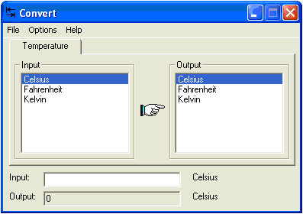
Figure 1: Convert Anything.exe

Specifications:

- The software shall allow the user to select the engineering units for the value that they will input as well as the engineering units that they would like to see on the output of the conversion.

- The software shall display Celsius, Fahrenheit and Kelvin as available engineering units for conversion.

- It shall be modular to allow a developer to add additional units of temperature if necessary.

- It should have an exit button or menu option for a user to exit the program when finished.

- It shall continue to perform conversions until the operator exits the application.

Reference:

K = C + 273.15

F = (1.8 * C) +32

